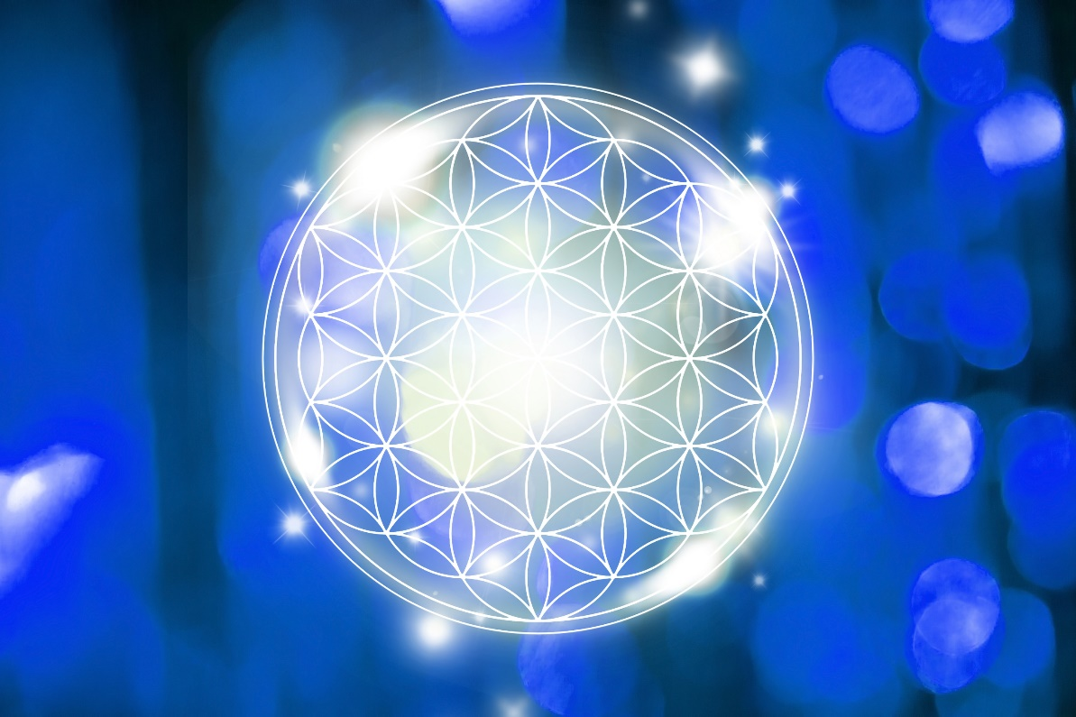

Divine I AM Original Blueprint Activation Codes Transmission
- Deep clearing and protection from negative energy
- Activation of soul remembrance and original blueprint
- Grounding of new energies of the Earth and beyond
- Upgrading your entire energy system and bringing through layers of protection
- Re-calibration of your DNA and cellular memory to reach the highest potential
- Activation of Oneness, Christ Consciousness and the Monad
- Activation of the original star vibration and the language of light

Hello and welcome to this beautiful healing space and congratulations for taking the steps to activate and reconnect back to self. It is an honour to serve your journey in this moment. You absolutely can experience deep love and joy that your soul desires in this lifetime.

This message is a reminder that what this universe is made up of is energy. We beings on Earth live within a reality that is vibrational. We are a soul and decided to have a human experience within a body and through this experience we master energy which is at the crux of alchemy and manifestation of all kinds.

When your energy is imbalanced, there will be an outward manifestation of chaos and disorder in the reality you see outside of you. As we begin to take our power back we learn how to clear, align, and create harmony within which gets reflected outwardly. These sessions and activations are powerful tools that assist in the process of uplifting and upgrading your energy system as well as shift into higher timelines.

When you have powerful activations the bridge you to the higher dimensions, higher self, ignite dormant gifts and codes. These activations also work on a global scale and the planetary grids to bring through a higher reality known as ‘New Earth’ built through divine love and unity consciousness.

This activation will infuse you with very higher vibrational light codes, clear dark energies and karma, and ultimately connect you back to your true original state of being and purpose. As you shift higher you will begin to feel calm, serene, supported and loved by this universe or God. There may be moments as you clear, however that the negative will be pushed up and out. Please do not be alarmed and allow this to occur. All is balancing from a cellular level of being.

When you use this activation regularly it will help you maintain a high vibration and higher level of consciousness. It will begin to shift you into your I AM presence and bring about healing, wellbeing and peace. These light codes will bring through deep love into your cells and DNA.

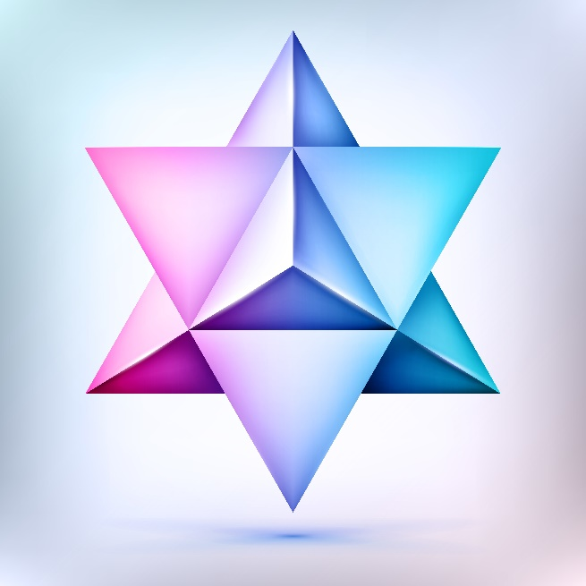

Before beginning, you may want to assist your process by clearing your field out with the symbol of a white rose clearing out any fears or doubts about who you are, your abilities or being able to create change. Have the rose also be dissolved into pure light after. Also, bringing up the image of a rainbow merkaba field around your body and asking for any lower energies or obstructions to connecting to your soul, Twin Flame or God to be dissolves into light.

Set an intention to be open in the heart and willing to receive this activation and healing to shift out of anything that has been holding you back. Ask your higher guides that are assisting you to be present and to be upgraded also so that you may receive as much out of the session as possible. You will then be ready to fully receive from a clear and higher state of being.

We are then ready to begin.

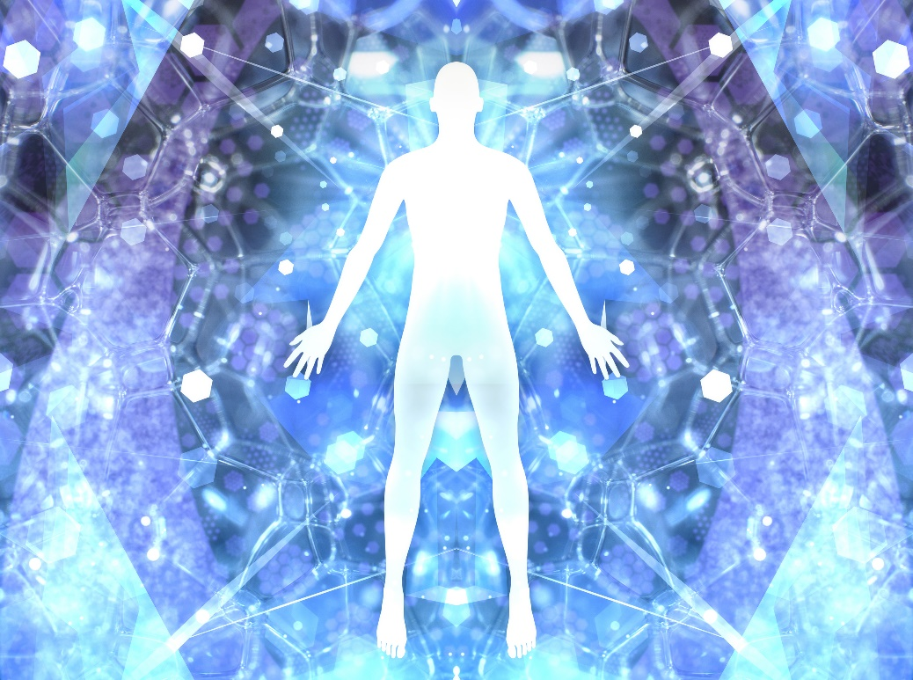

What is a Divine Blueprint?

Each Soul who has a blueprint and this blueprint is as unique as every soul within the universe. This blueprint holds a story you wrote and is seeded and birth into life. You have chosen to come through and live of both star and stone so you may learn, love and create through many facets of expression of Self in this multi-dimensional reality.

The blueprint you hold is an expression of energy containing light and sound that holds keys to open many different doorways and pathways of your divine plan. It is filled with higher divine potential to be expressed and experienced.

See the divine blueprint as like a design or a template. It is very much like the original recording of data. This is where all our original information and coding of pure light and sound are held. There are codes and records within the energy field that we originally held from our Source/Creator – The One.
This divine I AM Blueprint a spark within of the One Source Creator that was sent out to experience through multiple forms of light and sound. These are our life experiences and also of our Twin Flame’s and extended soul group’s experiences on Earth and other realms of existence. Through this blueprint we eventually return home and to our oneness of the cosmic heart through divine love.

It is my honour to assist in sharing an activation in this deep process of remembrance and to awaken fully to the AM presence. Along with listening to the audio activation I have included a visual activation to assist as well. This made be used to meditate on to further activate and bring through frequencies. I may be printed out and put on a healing table, bring to your bed at night, put under a chair and under food. You can use it wherever you think of to assist in you on all levels of being.

You may also copy them to your computer, mobile phone etc… to assist, heal, connect and balance your energies to the highest point.

What is important is the feeling within as the energy shifts and changes, whether immediate or over long-term use.

With love and divine blessing from my heart to yours. I am grateful to be connected and sending so much love on your continued journey.

An added note: if at any moment triggering and heavy energies occurs after the activation session, please know this is a part of the process and that means you have begun the shifting process to clear out the negative energy and that the actual blocks are moving out of your system. What you are feeling and experiencing are the old, stagnant negative energy shifting out and that is actually a good sign even if it feels uncomfortable. Please know it will definitely get easier the more you go and you can connect to simple ways to assist your process such a clearing the energy.

When uncomfortable energy arises remember to connect to your guides and to the source of light above you and bring it completely through your being and into the center of Earth, expanding to fill the entire planet. You may do this pillar of light connection at all times and affirm your clearing of dark energy whenever you need it. Bring through nurturing energies into your lower three chakras with the assistance of Kaun Yin and Mother Mary for your inner child.

At any moment you can connect to your Higher Self to help your shifting process out of any fear and back into the heart and divine love. Always remember you are an infinite being and all negative energy is simply that, its just like dirt that can be cleaned out. It is not dangerous and when you step into your power you will shift higher.

If at any time, you feel called to have a break, do so and allow yourself to integrate. You have a powerful intuition that is your guide and you can trust it. Over time, you will rise higher and higher in vibration and fully align on all levels of being. You will experience profound positive changes within and without.

With Divine love, Abigail xo

